A TSMU Student Won a Charitable Marathon

Under the slogan “The strongest are those who direct their strengths to good deeds!” On September 18 the second stage of the charitable marathon took place. Ternopil State Medical University also joined it.
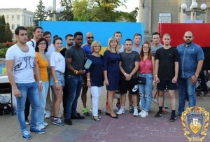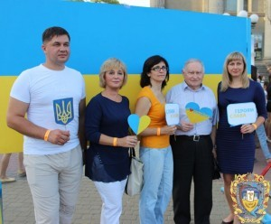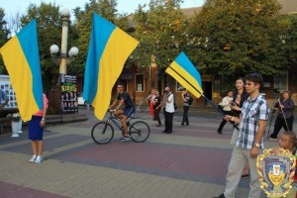
Ukrainian and international students of TSMU supported Ternopil citizens in raising funds to purchase an electroencephalograph for free examination of children suffering from epilepsy in Ternopil region. Our university teachers exhorted the youth to good deeds and also ran with them the distance of over kilometer.
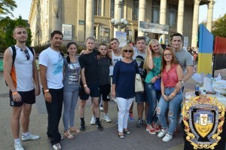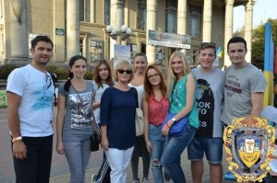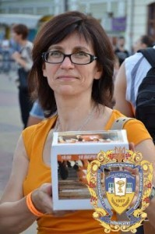
The first charitable marathon was held on May 23 this year and 33,121 UAH were raised within one hour. Today, the amount of money raised is 97 000 UAH. To buy the necessary equipment 150,000 USD is required. Nata Bench, Viktoria Farion, Sergii Sholomeichuk were the initiators of this drive.
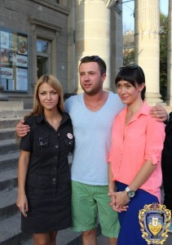
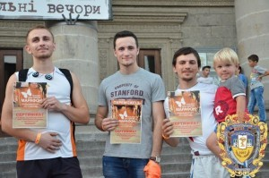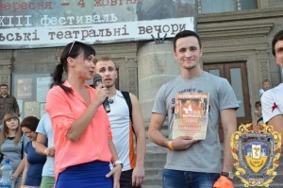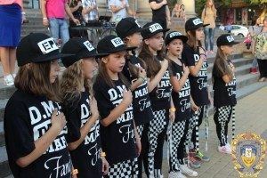
A student of the Department of Medicine of Ternopil State Medical University Mykhailo Dumnych won this marathon getting ahead of the participant for quite much time. Our international students also ran up the whole distance and made a donation to a noble work.
